Horseshoe Crab Program Attendee
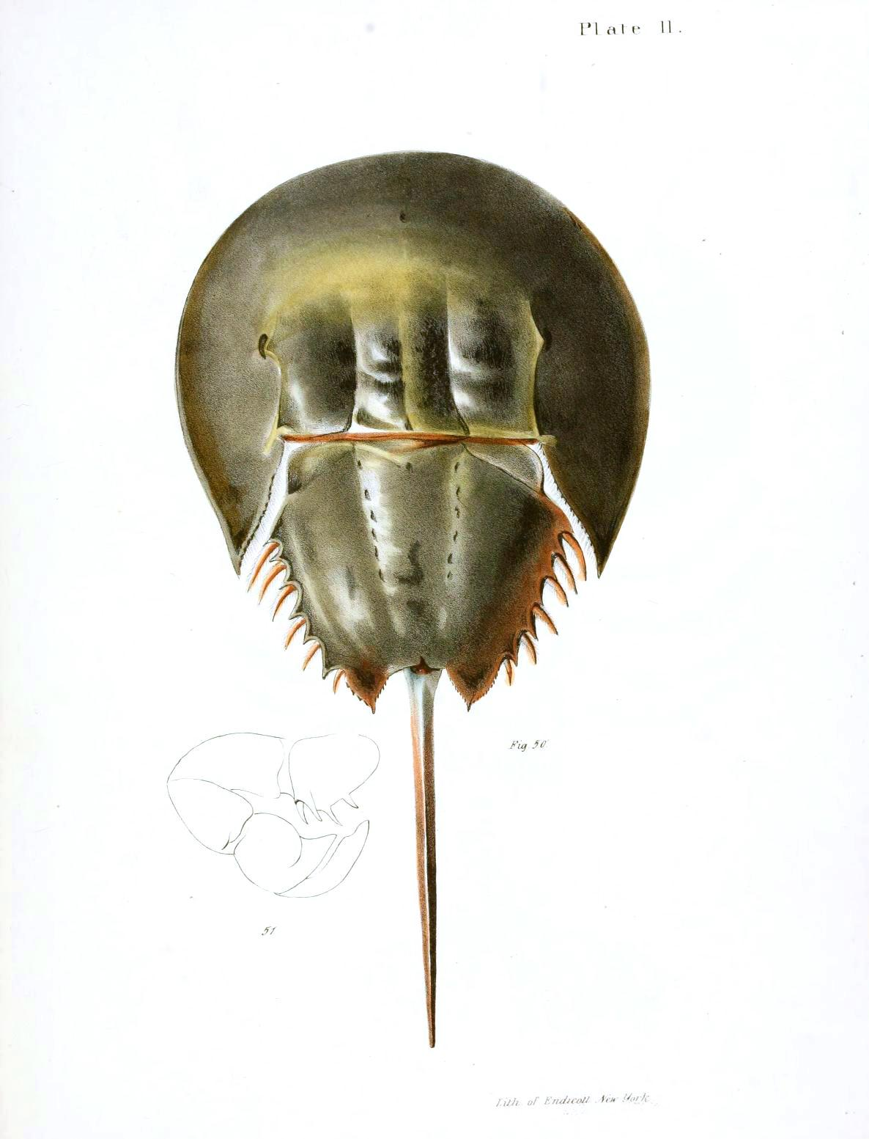
May 28, 2016

